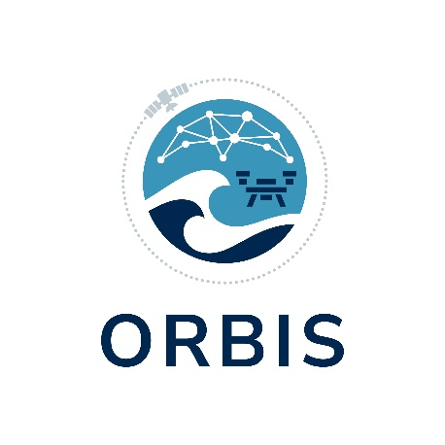

Project Coordinator: Katerina Margariti katerina.margariti@accelligence.tech
Dissemination Manager: Nikolay Premyanov premyanov@qplan-intl.gr
23/10/2025
ORBIS: A new Horizon Europe project has kicked off!
With the completion of our Kick-Off Meeting in Athens, Greece, the ORBIS consortium’s work on delivering a holistic and effective maritime border security solution has begun.
We are delighted to announce the official start of ORBIS, a 24-month Horizon Europe Innovation Action funded by the European Research Executive Agency. The project brings together a consortium of 6 partners representing a constellation of expertise that collectively brings great relevance to Mediterranean maritime security affairs:
ACCELIGENCE (Coordinators)
Q-PLAN International
Hellenic Coast Guard
FOUR DOT INFINITY
National & Kapodistrian University of Athens
ITOS3D Engineering
ORBIS will strive to deliver a market-fit, AI-powered, mature and cost-effective solution that integrates constellations of satellites with autonomous unmanned aerial vehicles (UAVs); to achieve advanced secure real-time surveillance, and fast search and rescue over vast maritime areas to ensure maritime border security.
The project’s technological development will address key civil security end user needs by going beyond the current boundaries in i) Integrating SAR, VHR satellites, and thermal infrared sources to achieve a continuous, high-accuracy monitoring system; ii) Leveraging advanced autonomous cost-effective UAVs and push their limits in terms of durability, autonomy, and sensing to support maritime border management applications; iii) Exploiting cutting-edge Machine Learning (ML) models to make the most out of available flight time and sea area coverage; iv) Effectively fusing the massive multi-modal data gathered during operation and train distributed ML models for real-time decision making that will ensure faster search and rescue of migration incidents.
ORBIS seeks to generate a tangible impact on the ecosystem by accompanying innovative technological development with deep study of market, regulatory, ethical and security requirements and engagement with key stakeholders to elaborate a truly fit-for-purpose and market-viable solution. The project’s best practices and lessons learnt will be documented and elaborated as clear replicable steps to act as a lighthouse case that paves the way for other small innovators in their go-to-market strategy. Finally, regulatory and policy recommendations will also be elaborated as signposts for facilitating access to and dynamism in the civil security market, aligned with EU security policy priorities.
Join us on this journey! Follow us on social media and stay tuned for more!
LinkedIn
X

